TW68XX

SDK Demo Program Instructions

Preliminary Technical Document from Techwell, Inc.

Information may change without notice

Disclaimer
This document provides technical information for the user. Techwell Inc. reserves the right to modify the information in this document as necessary. The customer should make sure that they have the most recent data sheet version. Techwell Inc. holds no responsibility for any errors that may appear in this document. Customers should take appropriate action to ensure their use of the products does not infringe upon any patents. Techwell Inc. respects valid patent rights of third parties and does not infringe upon or assist others to infringe upon such rights.
Table of Contents

1. Function Descriptions 3
2. Instructions of Running the Program 3
3. Video Capturing Display and Audio Capturing Display 3
4. Test Device I2C and GPIO 3
5. Real /Non-Real Time Mode and Odd/Even Field Separate Capturing Mode 4
6. Channel Parameter Test 5

Function Descriptions
This program demonstrates the following functions:
- Video and audio capture
- Video and audio data recording to AVI file
- Even field only video at odd/even field separate capturing mode
- Testing of device I2C and GPIO ports
- Selection of real time or non-real time mode
- Selection of odd/even field separate capturing mode
- Channel parameters configuration

Instructions of Running the Program
Please follow the following steps:
- Power off PC first, and then plug in TW68XX evaluation board
- Power on PC
- Install device driver according to system messages. The driver files are TW68XX.inf and TW68XX.sys.
- Run TW68XX.exe after all device driver programs are installed. TW68XX.exe file must be under the same directory with TW68XX.dll

Video Capturing Display and Audio Capturing Display
While TW68XX.exe is running, the captured video will be displayed if video inputs are connected with TW68XX evaluation board. The real time capture mode is the default mode. Video brightness, contrast, saturation and hue could all be adjusted at the left bottom of window.
The audio button controls the capturing of audio data. The audio capturing mode must be enabled in channel configuration, which is enabled by default.
If the odd/even field separate capturing mode is selected, the even field will be displayed when pressing “Field 2” button.

Test Device I2C and GPIO
I2C and GPIO can be tested by pressing the configuration button. Please refer the following figure.
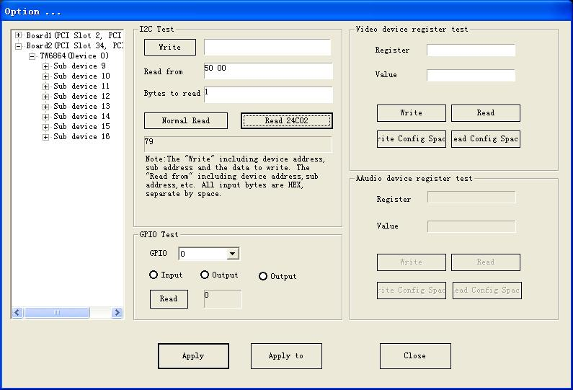

Real /Non-Real Time Mode and Odd/Even Field Separate Capturing Mode
In the “Configuration” window, two field separate capturing mode and real/non-real time mode can be selected respectively. If multi-channel CVBS inputs are selected, non-real time mode will be enabled. If one CVBS input is selected, then real time mode is enabled.
In real time mode, two fields separate capturing mode can be selected, of which is prohibited under non-real time mode. This mode will be enabled after pressing “Apply” or “Apply to” button. Please refer the following figure.
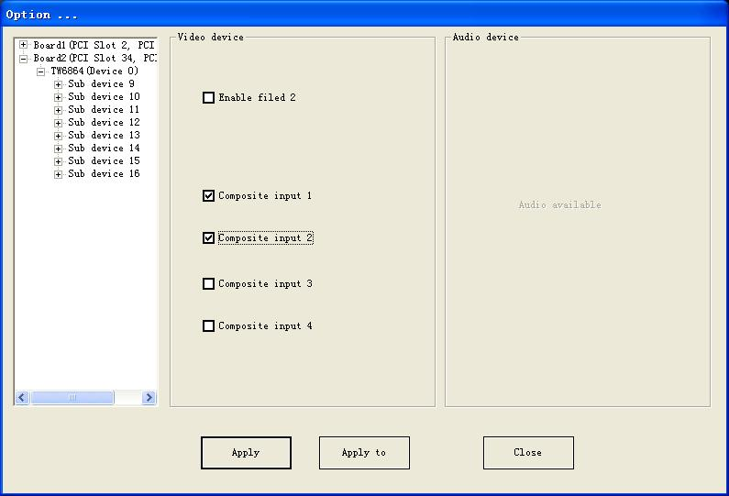

Channel Parameter Test
In the “Configuration” window, the video channel parameters can be configured, including video standard, resolution, pixel format, frame rate and the enabling of audio capturing. If separate two field capturing mode is enabled, the field rate, resolution and pixel format of even field can be configured. All new configurations will be activated after pressing “Apply” or “Apply to” button. Pressing “Apply to” also could duplicate the parameters to multi channels. Please refer the following figure.
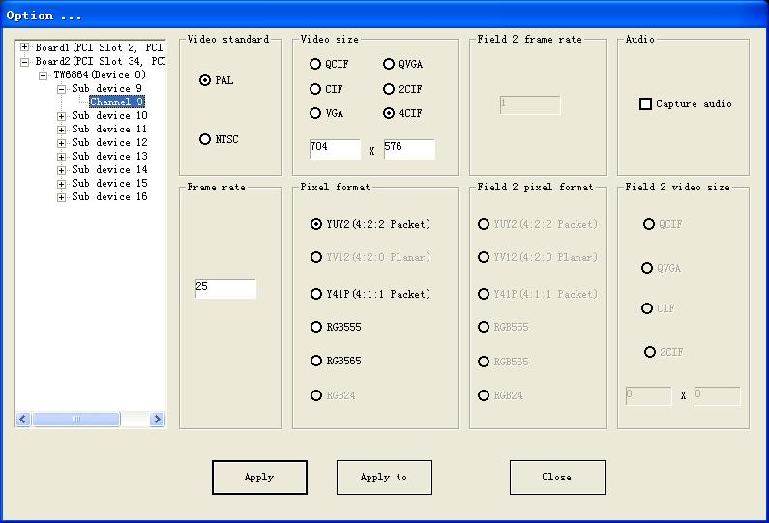
“Apply to”
